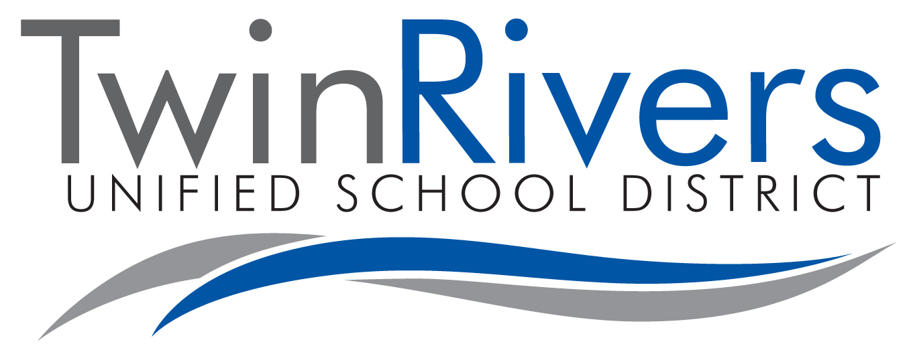
Twin Rivers Unified School District offers free income-based Early Head Start, Head Start and State Preschool programs. See the income guidelines listed below to determine eligibility.

listed below to determine eligibility.

INCOME DECLARATION FORM

2020

Head Start Program State Preschool Program
Family Size | Monthly Income | Annual Income |  | Family Size | Monthly  Income | Annual Income
1 | $1,063.33 | $12,760 |  | 1-2 | $4,173.00 | $50,077
2 | 1,436.67 | 17,240 |  | 3 | 4,502.00 | 54,027
3 | 1,810.00 | 21,720 |  | 4 | 5,256.00 | 63,083
4 | 2,183.33 | 26,200 |  | 5 | 6,098.00 | 73,177
5 | 2,556.67 | 30,680 |  | 6 | 6,939.00 | 83,270
6 | 2,930.00 | 35,160 |  | 7 | 7,096.00 | 85,163
7 | 3,303.33 | 39,640 |  | 8+ | 7,254.00 | 87,055
8 | 3,676.67 | 44,120
For family units with more than 8 members, add $4,480/year for each additional member. |  |  |  | Fees may apply based on income.
Parent/Guardian, please complete and sign below:

Child’s Name: _________________________________ Family Size: __________

Income from: Monthly Annual

Wages ____________ ____________
Self-Employment ____________ ____________
Supplemental Security Income ____________ ____________
TANF/Public Assistance ____________ ____________
Foster Child Income ____________ ____________
Adoption Assistance ____________ ____________
Child Support ____________ ____________
Unemployment ____________ ____________
Other income _____________ ____________ ____________

TOTAL: ____________ ____________

I give Twin Rivers Unified School District staff permission to verify the above income. I certify under penalty of perjury that the above information is true and correct. If any changes in income/family status occur, I will notify Twin Rivers School District immediately.

Parent Signature: ________________________________________ Date: ___________________

Staff Signature: __________________________________________ Date: ___________________

Rev. 1/27/2020

